Practical: 4
Project Definition
The objective of this project is to conduct a comprehensive analysis and visualization of Electric Vehicle (EV) sales data using Power BI. This is achieved by developing an interactive dashboard designed to illustrate key metrics such as EV market penetration, state-level performance, manufacturer market share, and temporal sales trends.
Learning Outcomes
- Proficiency in importing, cleansing, and modeling datasets within Power BI.
- Hands-on experience in creating dynamic dashboards utilizing a range of charts, slicers, and filters.
- A thorough understanding of how to analyze EV sales performance and penetration rates across diverse regions and vehicle categories.
Methodology and Tool
The analysis was performed using Microsoft Power BI Desktop. The methodology involved constructing a series of visualizations—including bar charts, line charts, donut charts, and maps—from a dataset containing EV sales, total vehicle sales, and manufacturer data. Interactivity was incorporated through filters and slicers to facilitate detailed analytical exploration.

Phase 1: Data Ingestion and Preparation
The initial phase involved importing the EV sales dataset (in Excel/CSV format) via Power BI's "Get Data" feature. Subsequently, the data underwent a cleansing process where extraneous columns were removed and headers were renamed for improved clarity. The data types for all columns (e.g., numeric, text) were rigorously verified to ensure analytical and visual accuracy. The imported data included fields for EV sales, total vehicle sales, and the calculated EV penetration percentage by state and year.

Phase 2: Data Modeling and Metric Creation
In the data modeling phase, relationships between data tables were established using Power BI's Model View to create a cohesive data model. Custom metrics, including Total EV Sold, Total Vehicle Sold, and EV Penetration (%), were engineered using Data Analysis Expressions (DAX) formulas. This structured data model is essential for enabling cross-filtering capabilities, allowing for detailed analysis across states, categories, and years.

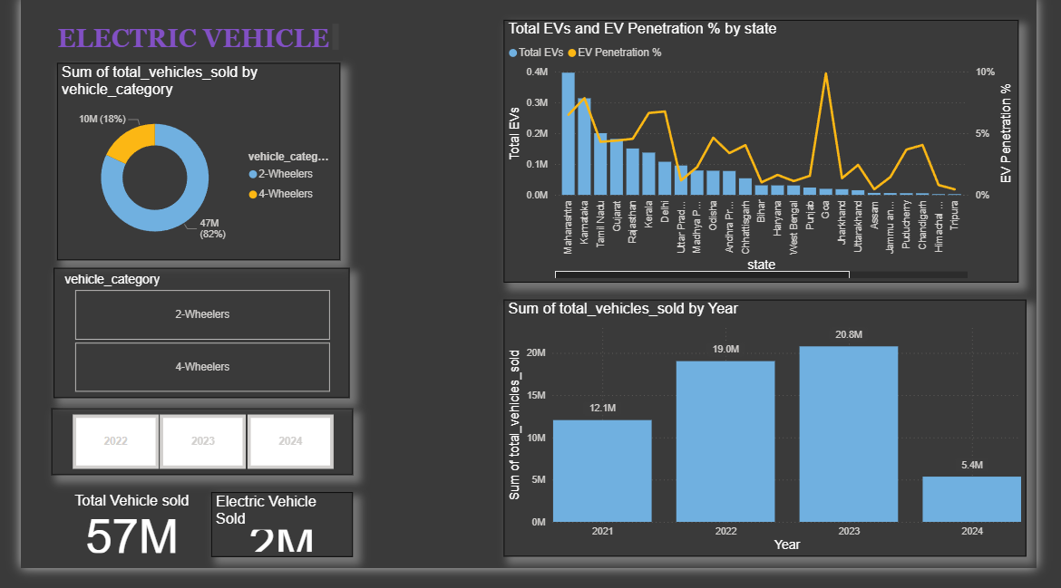

Step 1: Creating the State and Year Charts
I started by making charts to see how sales looked in different states and years.
- I used a combo bar and line chart to show both the total number of EVs sold and the EV penetration percentage for each state. This made it easy to see that states like Maharashtra, Karnataka, and Goa were doing really well.
- A simple column chart was used to show the total number of all vehicles sold each year from 2021 to 2024.
Step 2: Analyzing Car Makers and State Ranks
Next, I wanted to see which companies and states were at the top and bottom.
- I used bar charts to find the Top 3 and Bottom 3 EV makers (like OLA, TVS, and Ather).
- I created a similar section to show the Top 5 and Bottom 5 states based on their EV penetration percentage.
Step 3: Adding a Sales Map
To see the data geographically, I added an interactive map.
- I used a Filled Map to show total vehicle sales in each state.
- I made the map's bubbles change size based on the number of EVs sold and change color based on the penetration rate. This quickly shows EV hotspots like Karnataka and Delhi.
Step 4: Showing Vehicle Types
Finally, I wanted to see what kind of EVs people were buying.
- A donut chart was perfect for showing the sales split between 2-wheelers and 4-wheelers.
- The chart clearly showed that 2-wheelers are the most popular, making up around 82% of all EV sales.

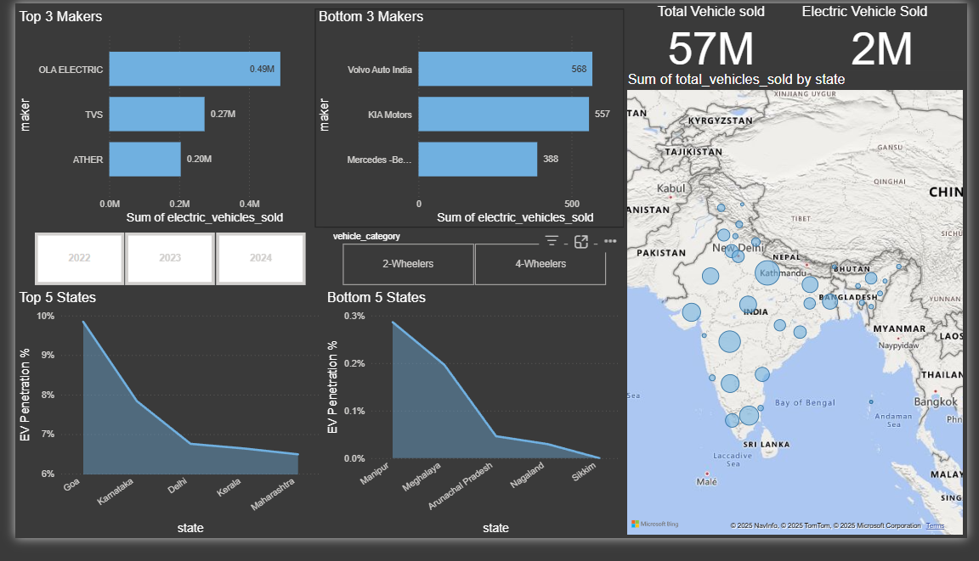
Step 5: Analyzing Sales Trends Over Time
To see how sales changed throughout the year, I created line and area charts to track the monthly and quarterly trends. This made it easy to spot any seasonal patterns, like predictable peaks and dips in sales performance. The screenshot shows how these charts map out sales patterns over time.
Step 8: Adding Interactive Filters (Slicers)
Finally, to make the dashboard user-friendly and interactive, I added a couple of filters known as slicers. I included slicers for the Year (2022–2024) and for the Vehicle Category (2-Wheelers and 4-Wheelers). As the screenshot shows, these allow anyone viewing the report to click and filter the data to see exactly what they're interested in.
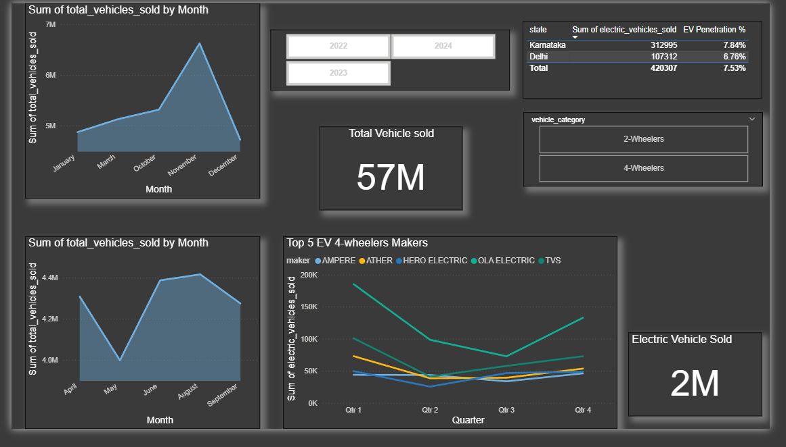

Step 6: Formatting and Dashboard Enhancement
- Consistent colour theme (green and white) was applied to represent sustainability and eco-friendliness.
- Titles, labels, and legends were formatted for readability.
- Cards were added to display key metrics like Total EVs Sold (2M) and Total Vehicles Sold (57M).
Description: Final polished dashboard presenting a professional and visually appealing EV sales report.

